Home Work 2 (2007-09-14)
Submission deadline: 2007-09-22

Question 1: What is difference between <<extend>>, <<include>> and use case generalization relationships in use case diagrams. Emphasize your answer by giving an example. (Bonus Point 01)

The difference between include and extend relationships is the location of the dependency. Suppose we are going to add few use cases for the actor Dispatcher, say, OpenIncident, AllocateResources, and ConnectionDown.
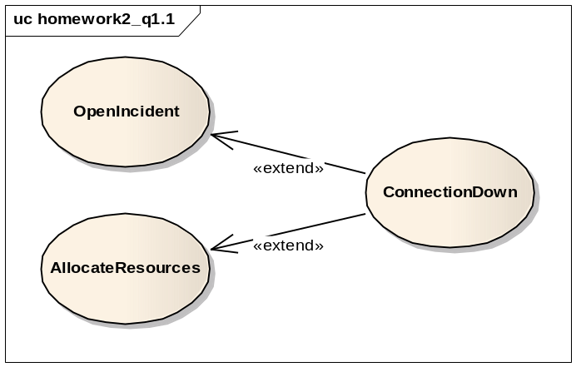
Figure 1.1
If we model the ConnectionDown use case with include relationships, the authors of OpenIncident and AllocateResources use case has to know about and include the ConnectionDown use case. Conversely, if we use extend relationships instead, only the ConnectonDown use case needs to be changed to extend the additional use cases. In short, exceptional cases are modeled with extend relationships, whereas common behavior shared by use cases are expressed by include relationships.

The extend relationships and generalization relationships are also different. In a extend relationship, each use case shows a different flow of events to achieve a different task. In Figure 1.1, the OpenIncident use cases depicts the actions which take place when the Dispatcher creates a new Incident, in contrary the ConnectionDown use case describes the actions that occur during network crisis.
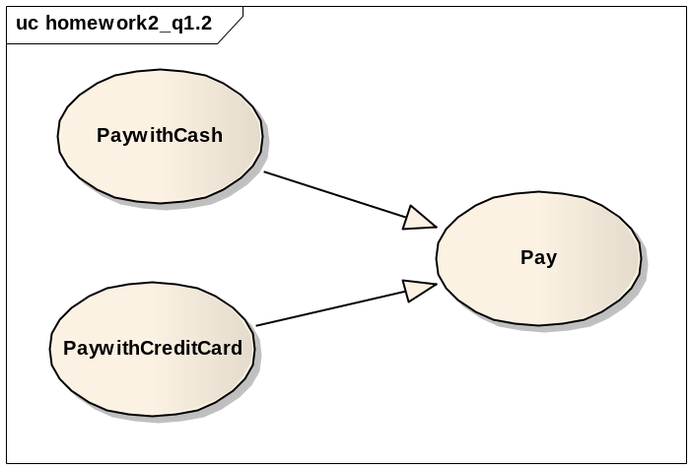
Figure 1.2
In Figure 1.2, PaywithCash and PaywithCreditCard both explain actions that occur during Payment, however at different abstraction levels.

Question 3: Consider the following Scenarios and refine the use case diagram given on page 03. You should create a new use case diagram, you should point out the places where other use cases get included, extended or generalized, and mark possible extension points.

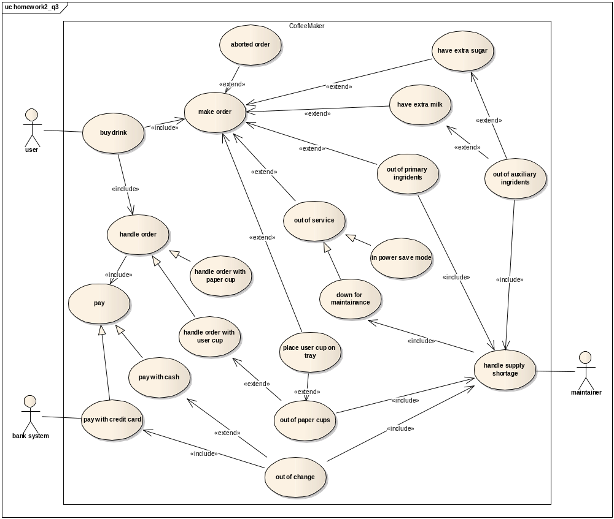

We arrange the use cases into three categories:
Exceptional use case:
aborted order, out of primary ingredients, out of auxiliary ingredients, out of paper cup, out of service, out of change
These use cases happens only under exceptional conditions.

Secondary use case:
have extra milk, have extra sugar, place user cup on tray, handle supply shortage
These use cases stands for the events that coffeemaker system takes care, but they are not mainly focused on.

All the rest use cases in the diagram are key use cases, which describe the core events that coffeemaker system is interested in, and normally the actor interacts with the system through these use cases.

Question 5: Consider an information system of an advertising consultancy company:

1. Glossary for the problem
Campaign
A campaign is a competition among a number of companies. In AdConslt software system, the term refers to advertisement campaigns, where each campaign can have a multiple advertisements, which could be of several types.

Timesheet
A timesheet keeps the track of the schedules and appointments assigned to a Staff, and it indicates the amount of in-office and out-of-office hours of consultancy a Staff has performed.

Template
A template is a form used in negotiation between Director and Client, the template consists of client information, type of campaign needed, resources, and campaign budget information, start and end time.

2. Identified actors of the problem (at least 3 actors)
Client
Company that is assisted by Advert Consultancy Inc to compete in an advertising campaign,

Staff
Staff provides consultancy to the Client, and present workload by the Timesheet.

Director (Department director)
Direct performs negotiation with the Client, and assigns staff to the client, each department in Advert Consultancy Inc has its own director.

Board of governor
Board of governor sees a summary of all active campaigns, utilization of staff, and current negotiations.

3. Identified scenarios of the problem (at least one for each actor)

Scenario name | startCreativeCampaign
Participating actor instances | david:Director  alice:Client  james: Staff
Flow of events | - Alice wants to take part into the advertisement campaign, and Alice goes to Advert Consultancy Inc to ask for consultancy for creating advertisements.  - David from creation department meets Alice, David negotiates the campaign with Alice based on a negotiation template.  - During the negotiation, David checks the current active campaigns with his department, and finds James is available, so David assigns James to Alice to consult with advertisement creation.  - David and Alice agree with the negotiation and sign the contract, the campaign becomes active.

Scenario name | workloadInChange
Participating actor instances | james:Staff
Flow of events | - James finishes his work by the end of Friday.  - James calculates the amount of hours of consultancy he has performed in this week.  - James figures out 30 hours in-office work and 10 hours out-of-office work.  - James updates his timesheet by writing down the amount of hours.

Scenario name | staffTransferBetweenDeparment
Participating actor instances | david:Director  scott:Director  micky: Staff
Flow of events | - David has an active campaign of creating advertisements.  - During the campaign, David discovers a network failure in his creation department.  - David gives a note to Scott about David’s need for Scott’s department staff.  - Scott receives the note, and check schedules in his department.  - Scott notices Mickey has free time.  - Scott assigns Mickey to David, and sends an acknowledgment back to David.

4. Identified use cases for the problem (at least 03 use cases). These use cases should be presented both as UML use case diagram and as textual description (see p. 163)

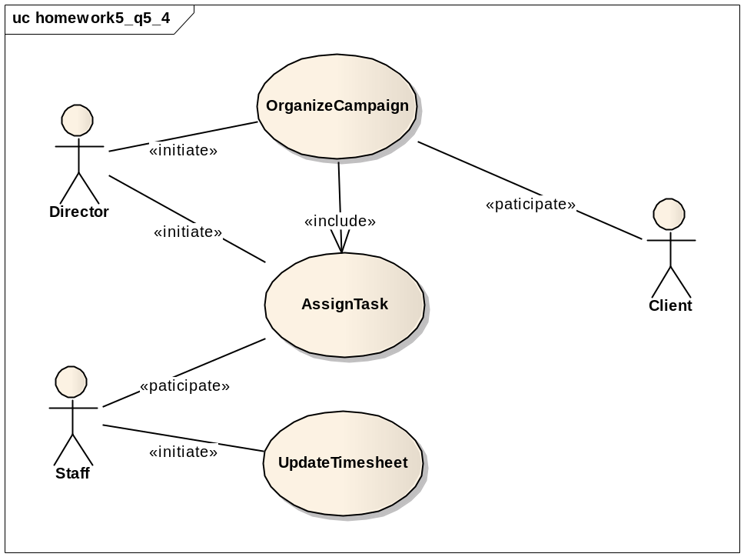

Name | OrganizeCampaign
Participating actors | Initiated by Director  Communicates with Client
Flow of events | - The Director requests the creation of a campaign.  - The system presents the Director with a negotiation form.  - The Client specifies the Client information, type of campaign needed, resources, and campaign budget information, start time and end time.  - The system checks the previous campaign records of the Client, if no record found, the system creates a new entry for the Client.  - Otherwise, the system appends the current campaign after previous records.  - The Director locates Staff to campaign (include use case AssignTask).  - The system compares the current global time to start time of campaign, if matched, the campaign becomes active immediately.
Entry conditions | The Director is logged into system.
Exit conditions | The ownership of the campaign is settled.  Client receives a copy of negotiation template.
Quality requirements | The negotiation template is presented from a secure channel.  The Director should be able to cancel settled campaign, as required by the Client.

Name | AssignTask
Participating actors | Initiated by Director  Communicates with Staff
Flow of events | - The Director requests a new assignment of Staff.  - The system presents the Director with an allocation form.  - The Director specifies the campaign and the Staff to be involved in the campaign.  - The system checks if the Staff is the department staff of current Director, if not, the system send a request note to the actual Director that the Staff belongs to, and wait for acknowledgement. Otherwise, the system updates the schedule of the Staff directly, and sends a popup message to inform the Staff.  - In waiting the acknowledgement, if the system gets no reply, it sends a popup message to warn the current issuing Direct, if replied, the system update the schedule of the Staff, and sends a popup message to inform the Staff.
Entry conditions | The Director is logged into system.
Exit conditions | The schedule of Staff is updated.  The Staff is informed by the change in schedule.
Quality requirements | The system waits for the acknowledgement from another Director no more than 5 minutes, if no reply, the system assumes the quest of Staff is refused.

Name | UpdateTimesheet
Participating actors | Initiated by Staff
Flow of events | - The Staff requests the list of his/her own schedule.  - The system presents the Staff with updates for schedules and new appointments.  - The Staff specifies the amount of hours of consultancy performed, further classified as in-office and out-of-office.  - The system updates the timesheet by add the hours given by the Staff, and the system automatically calculates the skill level of Staff based on the total workload time.
Entry conditions | The Staff is logged into system.
Exit conditions | The timesheet is updated.
Quality requirements | The system should list out all Staff that involved in certain campaign.

5. Refinement of the use case diagrams
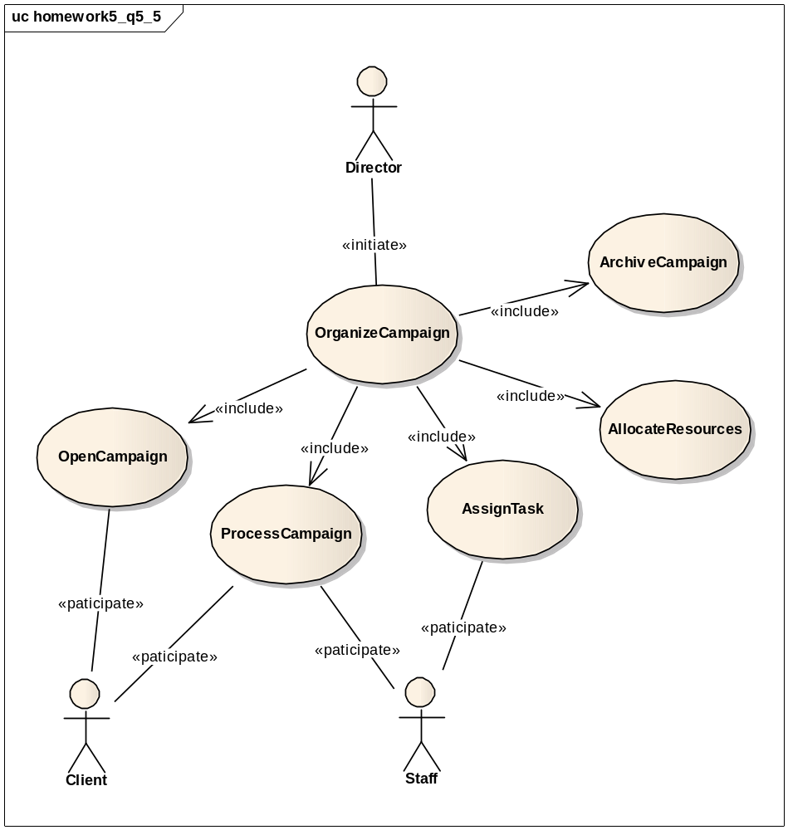
We do not show the complete refinement, we start by identifying one detailed use case for each step of the flow of the events in the high-level OrganizeCampaign. So OrganizeCampaign starts from OpenCampaign by signing up contact with Client, and Direct has to AssignTask to Staff regarding to the consultancy domain defined in the campaign, as well as AllocateResouces is invoked to reinforce the campaign with additional resources, the ProcessCampaign is carried out jointly between Client and Staff, Staff provides consultancy either in-office or out-of-office, eventually the campaign is done, and it will be archived as a record for further references.

6. One overview use case diagram with all the base use cases and all actors
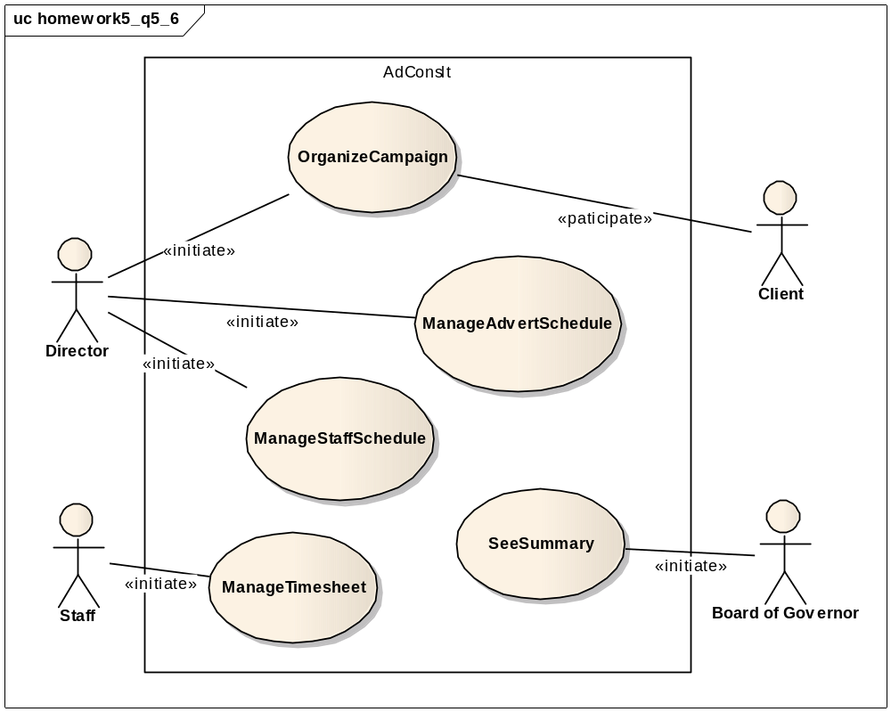
The above diagram gives high-level use cases identified for AdConslt (Advert Consultancy Software System), it focuses on primarily tasks accomplished by the actor.

OrganizeCampaign
Direct uses negotiation template to discuss with Client to create a campaign, and Direct allocates Staff and other resources to the campaign, and current record of campaign is kept in the system for further references.

ManangeAdvertSchedule
Direct changes the advert scheduling information according to the needs from Client, as well as Direct views current active advert scheduling information to plan resources for future activities.

ManageStaffSchedule
Direct allocates Staff to a campaign, if the Staff is not within the current Direct’s department, this Direct has to contact another department director about the need for staff.

ManageTimesheet
Staff sees the updates for schedules and new appointments, and Staff has to full out the amount of work as in-office or out-of-office latest by the end of the week.

SeeSummary
Board of Governor sees a summary of all active campaigns, utilization of staff, and current negotiations in process.

7. Extensions of the use case diagrams with exceptions handling
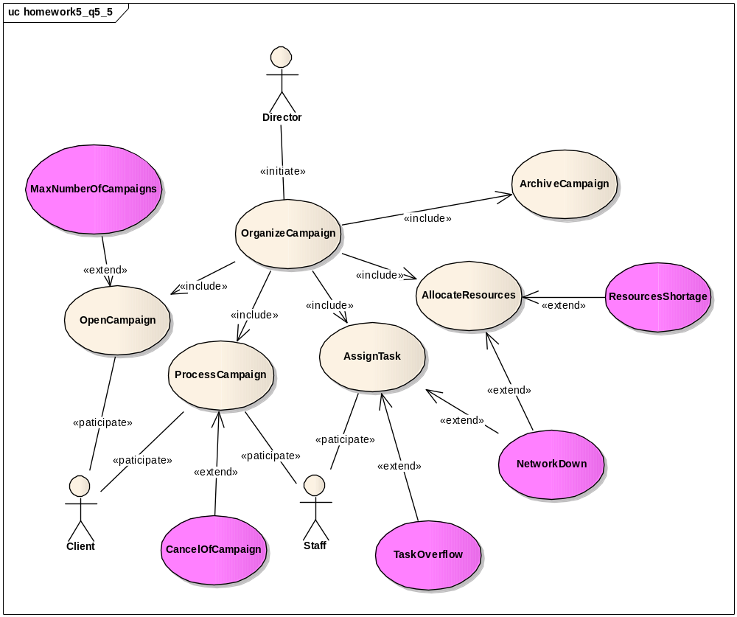
We define five exceptions that could occur during the detailed use case OrganizeCampaign in respect of resource constraints and application domain constraints.

MaxNumberOfCampaigns
The system has achieved the maximum limit of campaign that it can handle, the OpenCampaign use case is terminated.

CancelCampaign
The client cancel the ongoing campaign, the system asks director to confirm the cancellation first, and remove the campaign from current active campaigns list, release the tasks defined in the campaign, and inform the previously assigned staff about the changes.

TaskOverflow
Too many tasks are assigned to staff, or the system discovers a conflict in the schedule of staff, the system skips current task assignment and informs director to conduct a new task assignment.

NetworkDown
Network failure or crisis happens during the processing of task and resource assignments, the system tries to repeat the allocations in later time.

ResoucesShortage
The system detects a anemia of resources, the system attempts to arrange resource from other departments.

8. Description of non-functional requirements

Category | Nonfunctional Requirements
Usability | - The system should be shipped with user manual.  - The system should not throw technical error message to user.
Reliability | - Records are kept for all clients.  - The system automatically backups all records monthly.
Performance | - The system supports handling up to hundreds of ongoing active campaigns.  - The system generates list of schedules of campaigns or staffs with 5 seconds.
Supportability | - The director must be able to add new campaign.  - No modification of the existing system should be required.
Implementation | - The system should be implemented in Java programming language.  - The system is based on the combination of Struts, Spring and Hibernate.
Operation | - The director should not be able locate more resources in a campaign than a fixed limit agreed beforehand with the client during negotiation.
Legal | - The negotiation contents and the contract of the campaign should be treated as top credential.  - The director should be able to dismiss the consultancy agreement within a fixed period, as required by local laws.

